

ECS

ELECTRONIC CIGARETTE STORE

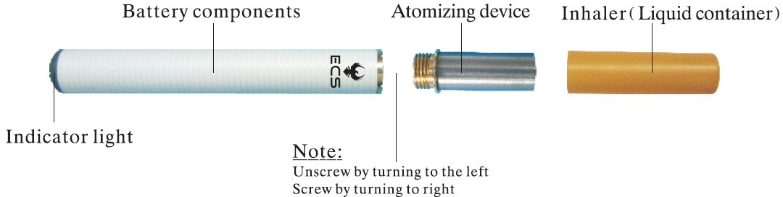

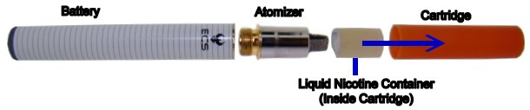

Using your electronic cigarette for the first time

Step 1

Remove the dummy cartridge from the atomizer (a dummy cartridge does not have a white plastic bucket inside of it)

Then unscrew the atomizer from the battery

Then charge each battery for 3 hours for the ECS 4081 and 1 hour for the ECS 88 model, if the LED light on the charger goes green before the time is up, do not remove the battery, let it charge for the full amount of time stipulated above.

Now that your have charged the battery it’s time to move on to the next step.

Step 2

Take a cartridge from its box, and then remove its plastic wrapper and silicone plug. If you take a look inside the cartridge, you will see a bucket like container with a wet piece of polyester wool, which is where the nicotine solution is stored, in the ECS 88 model it will be covered in a foil wrap.

Now screw the atomizer back onto the battery, and make sure you screw it tight so there is no gap between the atomizer and the battery.

Now put the cartridge back onto the atomizer and give the wick (the protruding part from the atomizer) a few minutes to absorb some of the nicotine solution before you use it, this is important.

Now feel free to use the electronic cigarette.

Caution: The 1st few drags do not always taste great as there is a primer fluid in the atomizer to keep it moist, do not worry it is safe and the taste will improve.

Note: Do not put your fingers over the air inlet holes when you inhale, they are those little open rectangular slits where the atomizer and battery join. The only time we ever suggest covering one inlet hole is if you drag is too easy and you not getting much vapour.

If you start tasting the nicotine solution in your mouth please read “How to stop getting nicotine in your mouth”.

The best way to inhale

The best way to smoke the device is to take a drag just hard enough to light up the LED at the tip of the battery, and then continue to suck steadily for about 4 seconds, while keeping that LED light on. Sucking really hard does not produce much more vapour, sucking slow and long is the secret.

Why am I not getting much vapour?

There are a few possible reasons:

There is not enough liquid nicotine making it to the heating coil.

Solution: drop the nicotine solution directly onto the wick

You are not taking long enough drags.

Solution: Inhale longer

The battery may be running low and there is not enough charge to heat the coil to the correct temperature.

Solution: Charged Battery

Tips for more Vapour

The best way to continually produce a good amount of vapour and get the most amount of flavour from your liquid nicotine is to use a technique referred to as the “dripping method”; the idea is that instead of refilling the cartridge when it is empty you put two drops directly from the cartridge refill bottle onto the exposed part of the atomizer each time you feel like a smoke.

This way you do not have a hard time trying to refill empty cartridges with a needle and syringe, you may also find that you get a lot more taste and vapour from the electronic cigarette this way. If you wish to fill your empty cartridges using a syringe please continue to read.

How to use the electronic cigarette with out refilling cartridges aka “dripping method”

Before you can apply this method you will first need to remove the liquid container inside the cartridge as you will no longer need it, removing it will also improve the ease of draw on the electronic cigarette and also reduce the chances of sucking nicotine into your mouth by 100%.

To remove the liquid container take a paper clip or similar size object and insert it into the mouth end of the cartridge and push the liquid container out, alternatively you can use the empty dummy cartridge that was originally on the electronic cigarette when you first opened the packaging. Once this is done you are ready to start “Dripping” see image below.

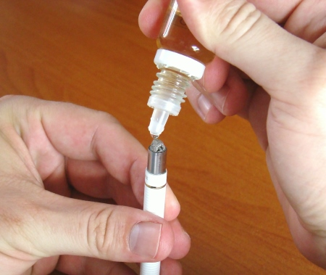

Drip 2 drops directly onto the atomizer wick

When applying this method you should get about 7 to 10 inhalations per two drops, if you require more nicotine after 7 to 10 inhalations add another drop or two, never add more than two drops.
After adding two drops to the atomizer, put the cartridge back onto atomizer and smoke as normal.

Remember for best effect take slow long drags not fast long drags. Sometimes it helps to create more pressure by blocking one of the slots that you can see where the battery and atomizer screw together.

Why do I sometimes get clouds of smoke and other times very little?

You may have noticed that sometimes while using your electronic cigarette you will get clouds of smoke and at other times you get very little.

I will try to explain why this happens and how to fix the problem so that you get consistent amounts of vapour most of the time.

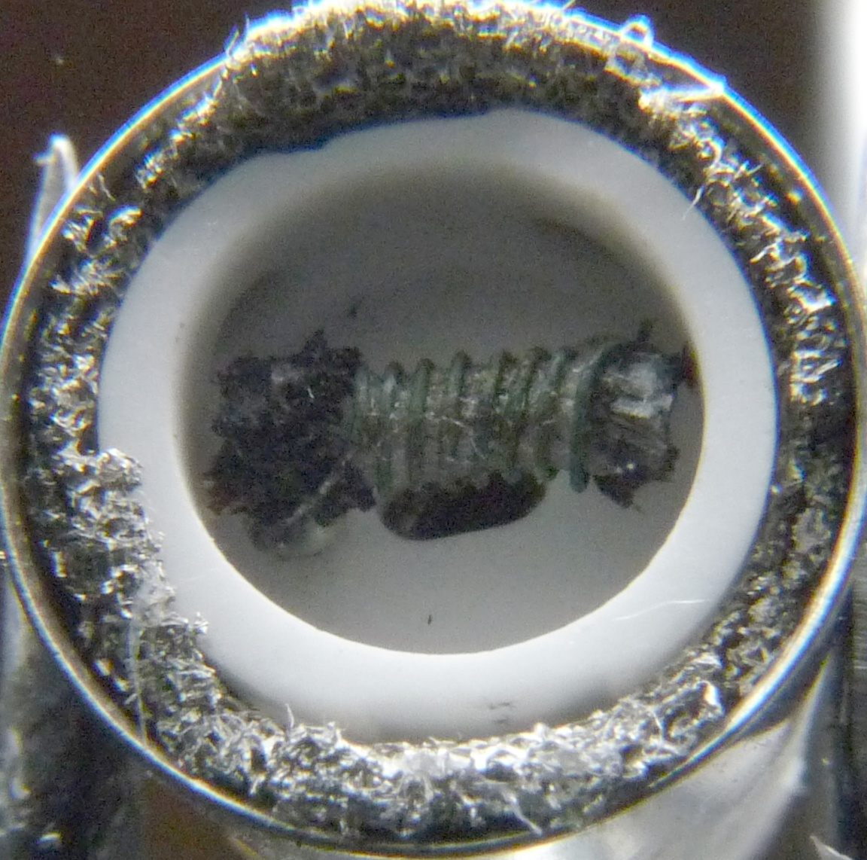

Image of heating coil under the metal arched wick

In the image above you can see the metal heating coil, which is wrapped around a wick, when you add drops to the atomizer or put a new full cartridge on, the wick gets moist, when you take a drag the coil glows red hot just like a toaster wire, as this happens the liquid nicotine in the wick vaporizes and produces the vapour that you inhale.

The reason you might be getting to little vapour is because the wick is to wet.

I will try to explain, when you take a red hot piece of metal and you stick it in to a drum of water you are going to get very little steam come off the hot metal, however if you just splash a little amount of water on the red hot piece of metal you are going to get a lot of steam.

Now if there is too much liquid nicotine around the wick the same rule above will apply, the excess liquid will not allow the coil to get hot enough to produce enough vapour, the excess liquid will act as a coolant on the coil. So in an ideal situation you want the wick to have correct level of moisture to produce the most amount of vapour.

So if you getting to little vapour and you want to get more vapour you need to reduce the amount of liquid nicotine in and around the wick.

To do this remove the cartridge from the atomizer and remove the atomizer from the battery, turn the atomizer up side down and blow into the small hole on the top and catch the excess liquid the comes out of the atomizer with a tissue.

Then re assemble the electronic cigarette, start using it again until you start getting a good amount of vapour, once you get a good amount you can start adding drops again, you will soon start to learn when to add drops so that you do not get the wick to wet and not to dry, you will know when it is to dry as the flavour will start tasting different to you.

Please note there could be other reasons you are not getting a good amount of vapour, but the above reason is the most likely reason.

How to refill empty cartridges:

Step 1
Remove the smaller inside container from the cartridge with a paper clip or similar device by pushing through the small hole at the mouth end of the cartridge.

Step 2
Using a syringe and needle extract the correct amount of nicotine into the syringe usually about 0.3ml.

Step 3
Insert syringe into the smaller inside bucket container, make sure you push the needle to the bottom of the container, then slowly press on plunger till the polyester wool is soaked, do not allow a pool of nicotine to form on top of the wool, if you do just absorb the excess fluid with a tissue or the syringe.

Step 4
Place the liquid container back into the cartridge and push it down to the bottom. Then place the cartridge back onto the atomizer and allow the wick a minute or two to absorb the nicotine.

Alternatively put the silicone stopper back into the cartridge and use when required (ECS 4081 only). A refilled cartridge should give you between 4 and 5 cigarettes worth before requiring another refill, this is also dependent on the model electronic cigarette you are using.

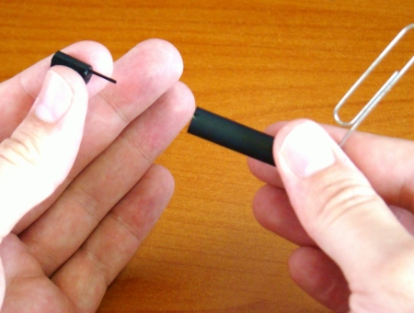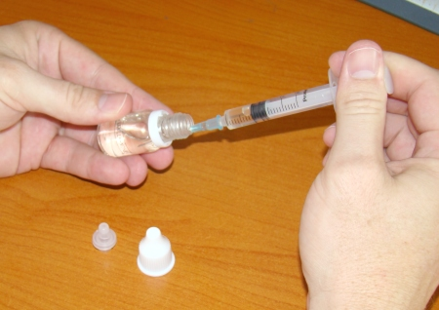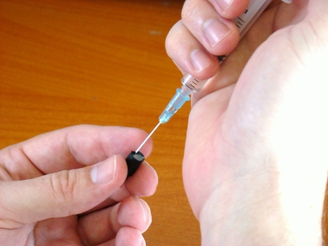

Step 1 Step 2 Step 3

How to stop getting nicotine in your mouth

First you need to understand how the nicotine gets into the mouth. There are two possible reasons.
- You have a vacuum cleaner for a mouth, and you sucking to hard.
- During shipping the cartridges get shook up and the fluid in the inner cartridge spills over into the air flow channel "those half circle shapes inside the cartridge", when you inhale the spilt fluid is sucked up the air flow channel and into the mouth. If this is happening follow the steps below to dry the cartridge out.
Step 1
Remove liquid nicotine container by pushing a paper clip through the mouth end hole of the cartridge.

Step 2
Get an ear bud or a tissue and roll the end up, see picture below. Insert the ear bud or tissue into cartridge and dry the cartridge out.
Step 3
Dry the outside of the liquid container with a tissue, try not to let the tissue touch the polyester wool.
Step 4
Insert the liquid container and push back into place with paper clip.
Step 5
Hold the electronic cigarette upright (cartridge side up) for a few minutes before using, to let the wick absorb some nicotine fluid, then start as normal. If you still getting nicotine in your mouth repeat the above steps.
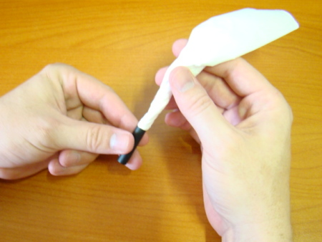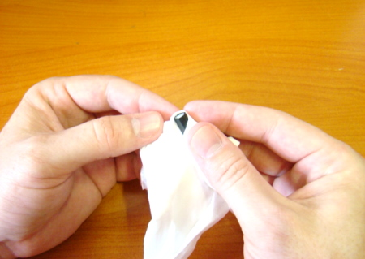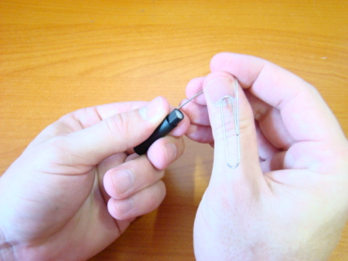
Step 1 Step 2 Step 3 Step 4
Remember: you should only be dragging hard enough to get the LED light to come on, and then inhale for about 4 seconds.
How to maintain your electronic cigarette

Although the atomizers and batteries are not built to last forever there are a few things you can do to prolong their life expectancy.
What you should know about atomizers.
The atomizer is a very fragile device, and should be treated as such. The atomizer is by no means a perfect vaporizing instrument yet and we are hoping that in a next couple of months we will see great improvement in its design and durability across all 8 of the worlds leading manufactures of this device.
The atomizer coil the part that heats and vaporizes the liquid is a very fine coil very similar to that of a light bulb filament, just not quite as thin, which makes it easy to break due to over heating, dropping it on the floor or the person on the production line having done his job properly on that day.
For this reason we highly suggest you buy a spare if finances allow for it, as it is difficult to gauge how long it may last, it could last 2 days it could last 6 months, no one really knows with atomizers, and that is true for all brands of electronic cigarettes.
Please do not see this as us trying to put you off this priceless new invention, that has helped thousands of people just like you improve the quality of their lives, but rather as a way of us been completely honest and up front with you from the start, atomizers do stop working from time to time. Please note that you are covered by our 3 month replacement warranty should this ever happen to you.
Caring for and Cleaning the Atomizer

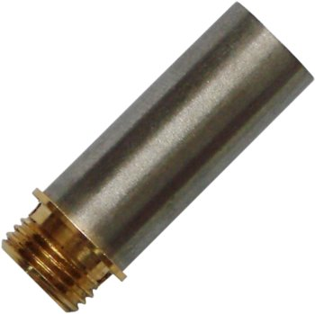
To clean the atomizer we suggest that you give it a rinse every 3 days before going to bed, to clean grab the atomizer with some tweezers or tongs and rinse under a hot water tap for a few minutes (do not forget the plug), then blow into the battery end of the atomizer to remove any excess water, then this repeat process a few times, you could also use some compressed air to do this, then place the atomizer up side down in an egg cup or something similar with tissue paper in it and allow to drain and dry over night, in the morning you must put at least 3 drops onto the wick, then give it 10 minutes to be absorbed before using. There are other ways to clean the atomizer however we think this is one of the safest and easiest ways to clean it.

Note: It may take a good few drags to get the atomizer back into action again (20 to 40 drags)

Why does an atomizer break?

How long an atomizer lasts, has much to do with luck and the users understanding of how the atomizer works. I will try to explain.

The atomizer works like this:

The cartridge holds the nicotine solution, the metal wick on top of the atomizer absorbs the nicotine from the cartridge and transports it to a plastic or ceramic bucket under the wick, in the bucket there is a rod (or second wick) which lays across the middle of the bucket, wrapped around this second wick is a fine wire called the heating coil.

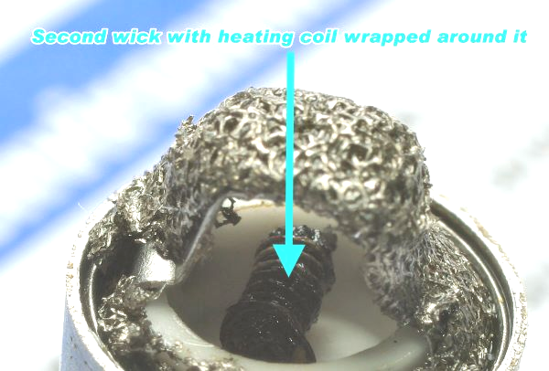
Once the nicotine solution is draw into the bucket the second wick absorbs it, when you take a drag the heating coil glows red hot like a toaster wire and vaporizes the nicotine solution in the second wick and produces the vapour that you inhale.

Now the nicotine has a second purpose here, the nicotine solution also acts as a coolant for the heating coil, so if the second wick is to dry the coil burns hotter than it should, if this happens to often it will become weaker and more fragile and is likely to break.

The best way to prolong the life of the coil / atomizer is to:

- Make sure it is always moist, by giving the second wick time to absorb the nicotine from the cartridge or the drops before you use it.
- Do not smoke it till it gets dry, when the vapour production gets less, either add more drops or stop smoking. If you start to taste a funny metallic or burning taste when smoking you need to put more nicotine solution onto the wick.

Why does the atomizer performance drop over time?

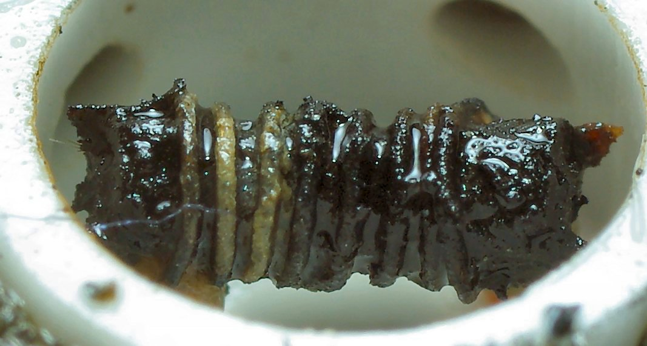
The atomizers performance will eventually drop i.e. produce less vapour over time, this is due to the second wick getting clogged with carbon, the carbon is deposited on the heating coil when the nicotine solution is vaporized, because the carbon is taking up space in the wick, it is no longer able to absorb as much nicotine and so the atomizer is unable to produce as much vapour.

Tip: Every week you can soak the atomizer in Coca-Cola for approximately 6 hours, the acid in Coca-Cola will help loosen carbon that has built up on the heating coil and this should prevent the heating coil from clogging up quicker than it should, do not forget to rinse the atomizer with water afterwards and dry as normal.

Cleaning the Battery

After using your electronic cigarette for a few days you may start to notice a green or black substance building on the battery thread and head, we suggest you clean the battery every few days if required.

To clean, dab some cotton wool with surgical spirits or any other spirits and then wipe it clean.

General things you should know about your device.

- If you go into a night club with loud music playing it may activate the battery so we recommend you detach the atomizer from the battery till you are ready to use it.
- If you prefer filling your cartridges, you should know that it is ok to rinse out the polyester wool inside the cartridge with warm water if you want to, if it gets old you could buy some from a pet shop, it’s the stuff they use in the fish tank filters.
- Sometime you may hear a whistling sound or a crackling sound coming from the atomizer, if you hear crackling it is most likely the nicotine boiling on the heating coil, and there is really nothing you can do about this. If you hear a whistling sound it is most likely the cartridge that is not a good fit on the atomizer sleeve, try changing the cartridge.

